**Multicloud Project Based Internship at IOC**

**Name**: Arti Panjabrao Mule

**Ambassador Name**: Atharav Panchpor.

**College Name**: Deogiri Institute of Engineering and Management Studies.

**TASK:**

Launch one T2 micro type windows server instance on AWS. Configure an IIS server with default web page.

1. Open the [AWS EC2 Management Console](https://console.aws.amazon.com/ec2/v2/home)
2. Click **Launch Instance**

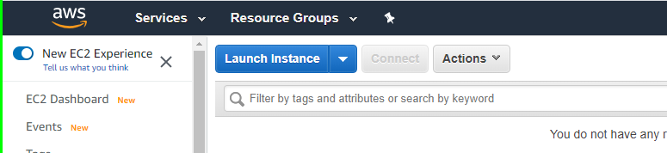

1. Select a Microsoft Windows Server instance (you may want to start with one that is “free tier eligible”

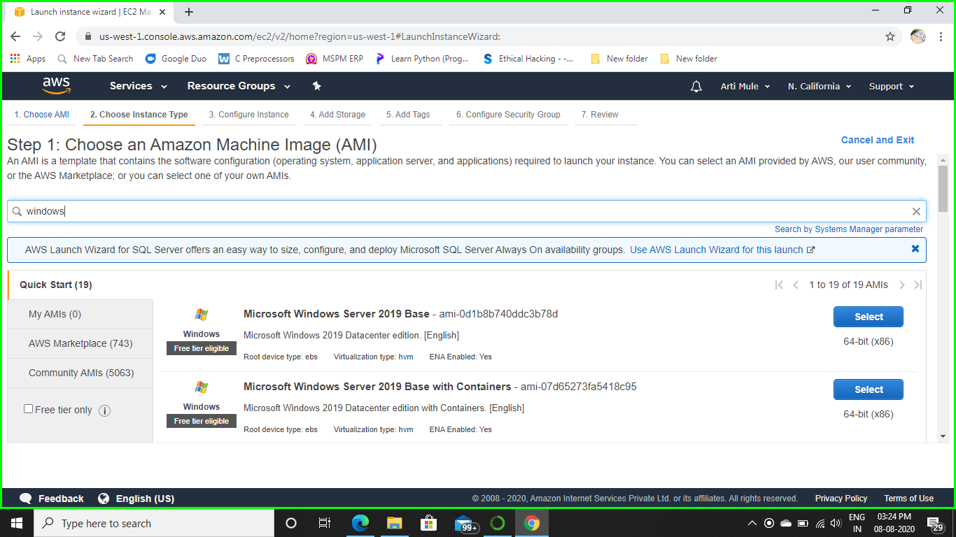

1. Choose an instance type (t2 micro-free-tire eligible)

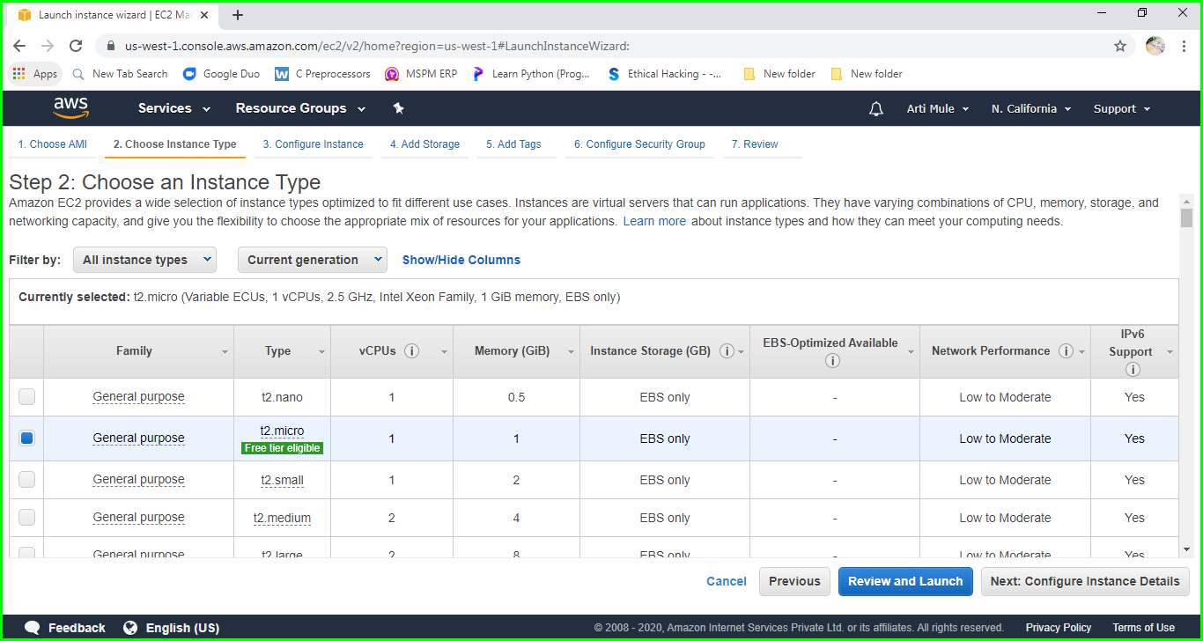

Since we are launching a simple instance click on Next: Configure instance Details, if you may skip all the steps then click **Review and Launch.**

1. Select an Configure Instance Details you may be keep default or change it yours choice, I keep default Instance details and click on **Next: Add Storage**.

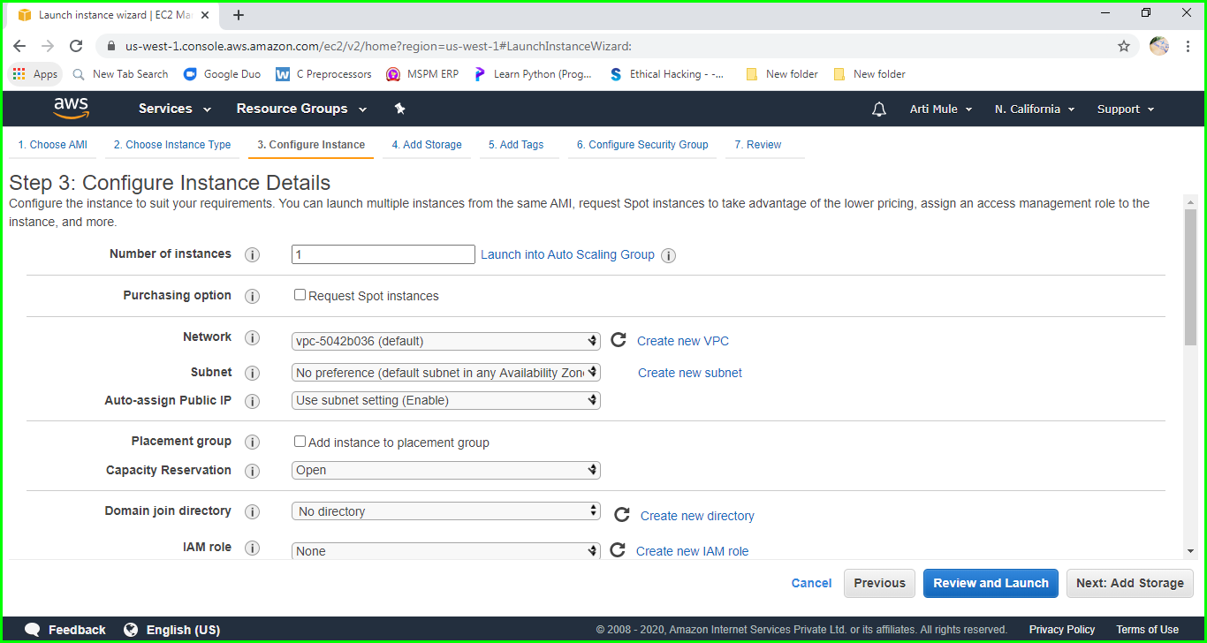

1. Keep the default Storage and click on Next: **Add tags.**

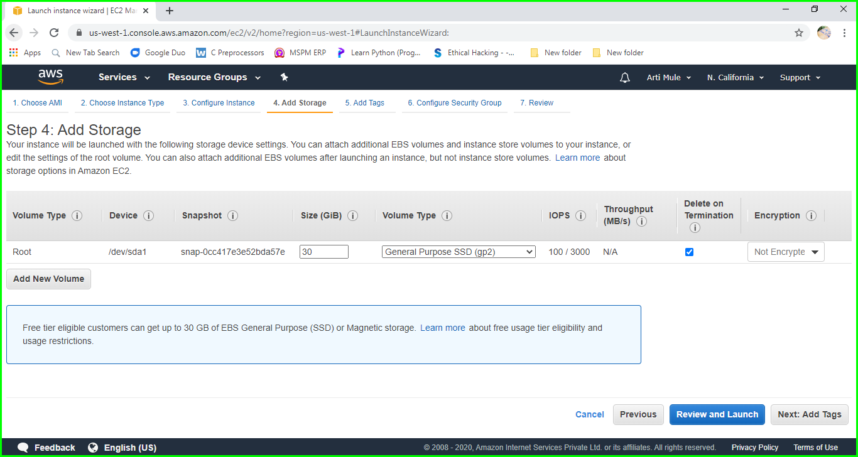

1. Keep it as it is and go ahead.

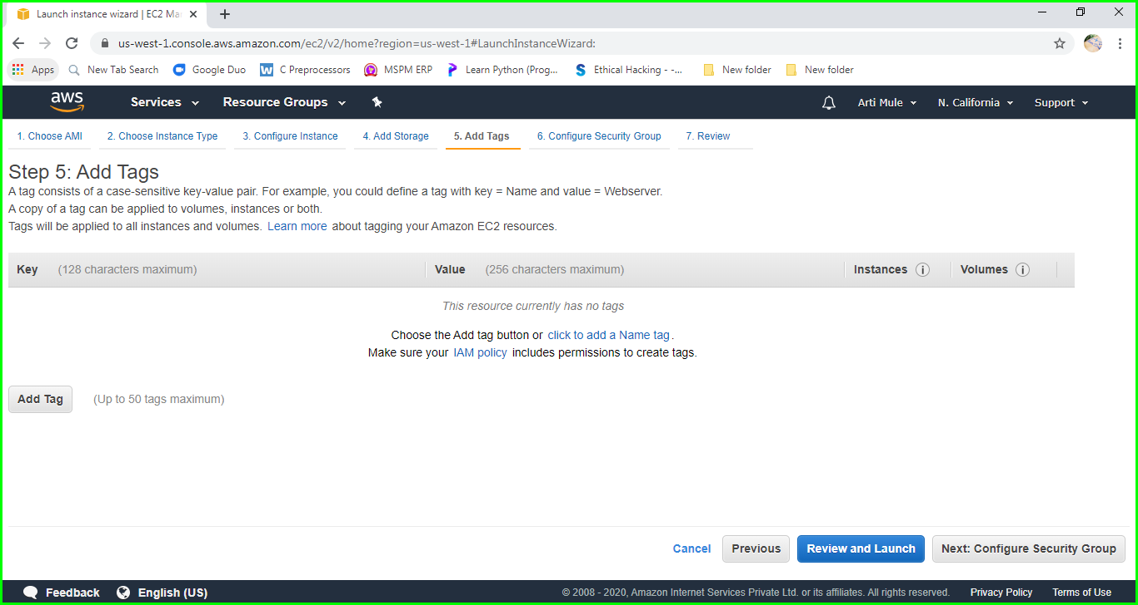

1. Keep default Security Group and click on **Review and Launch.**

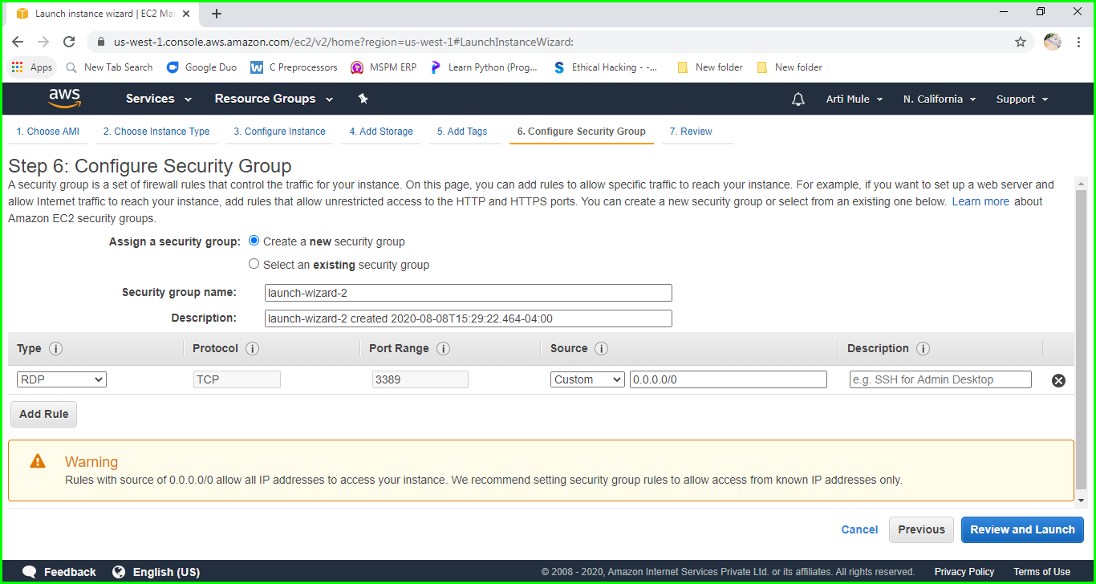

1. Launch Instance by clicking Launch.

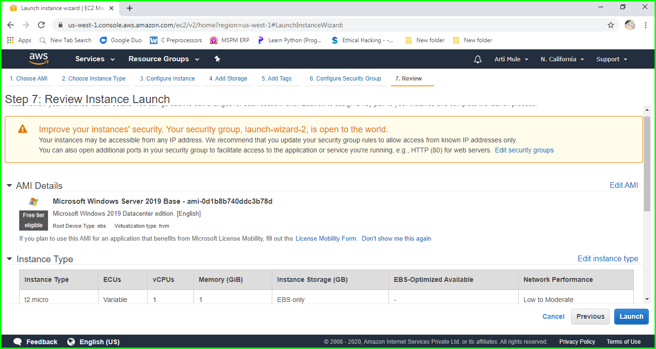

If you want change anything can you choose which you want to change and click on edit and change it, otherwise click on **Launch**.

1. Once the Instance is launched this screen will appear click on **View Instances**.

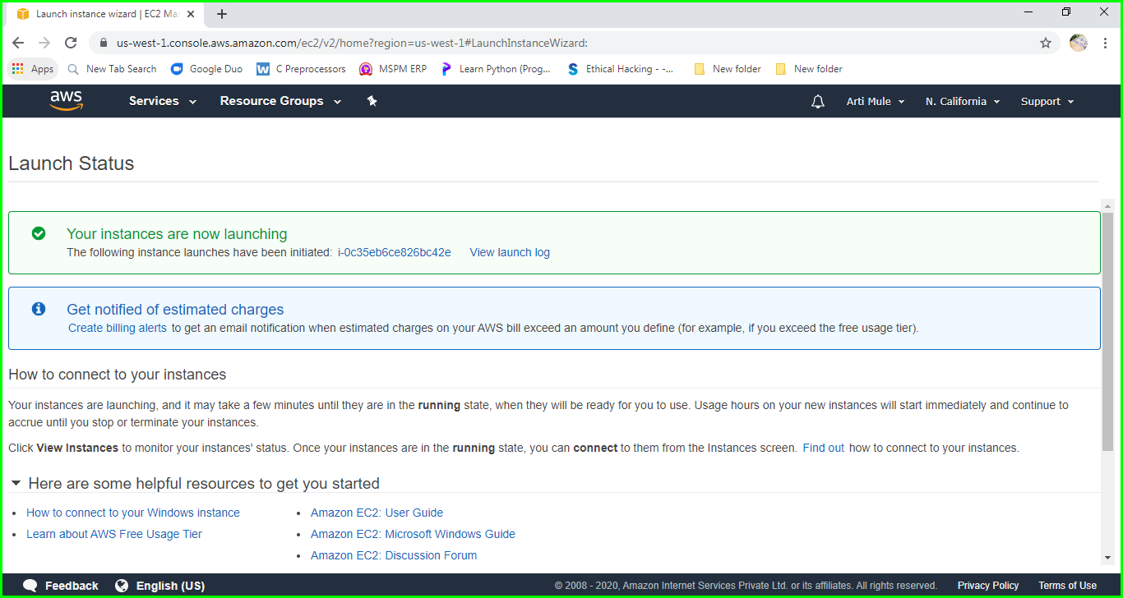

1. Then we will see this window, now open the Remote Desktop with the IPV4 Public IP of Instance then enter Username and Password. (We will get this Username and Password by Clicking **Connect**).

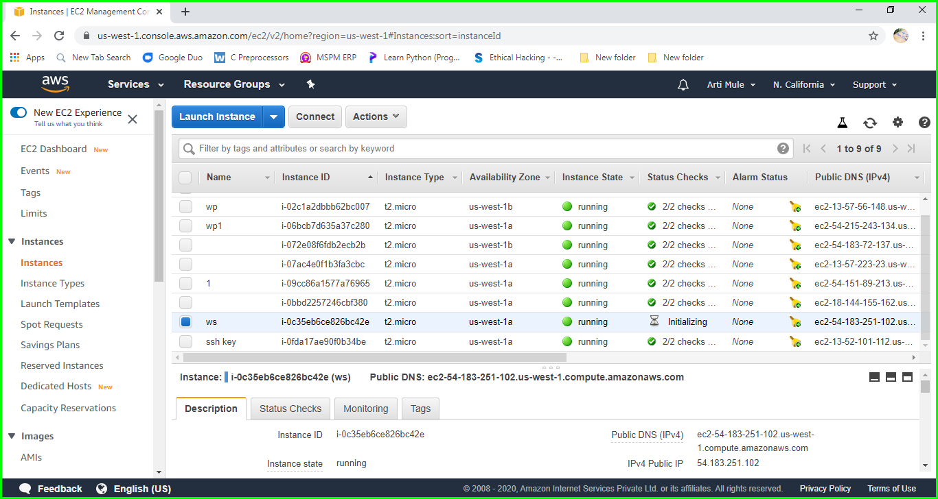

1. Once we have entered the username and password our remote desktop will start and the below screen will be appear.

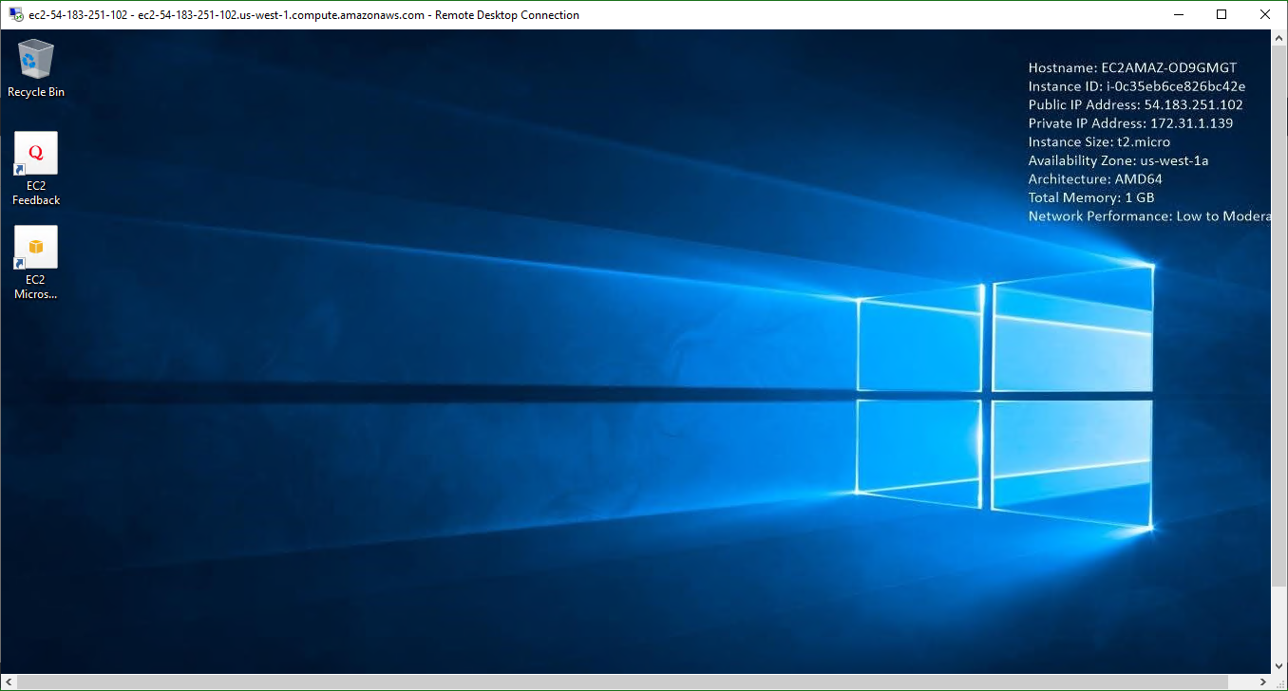

1. Now go to Sever Manager and Click Add role and Features then the below screen will appear.

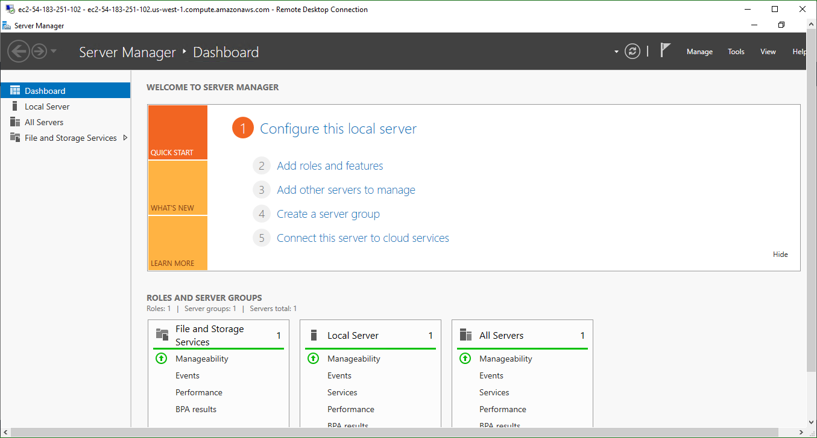

1. Click Next.

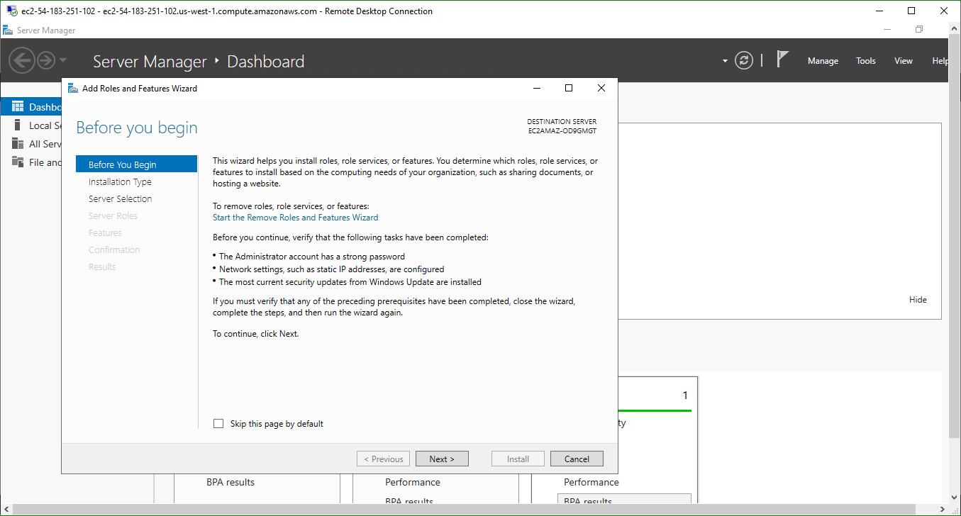

1. Click Next.

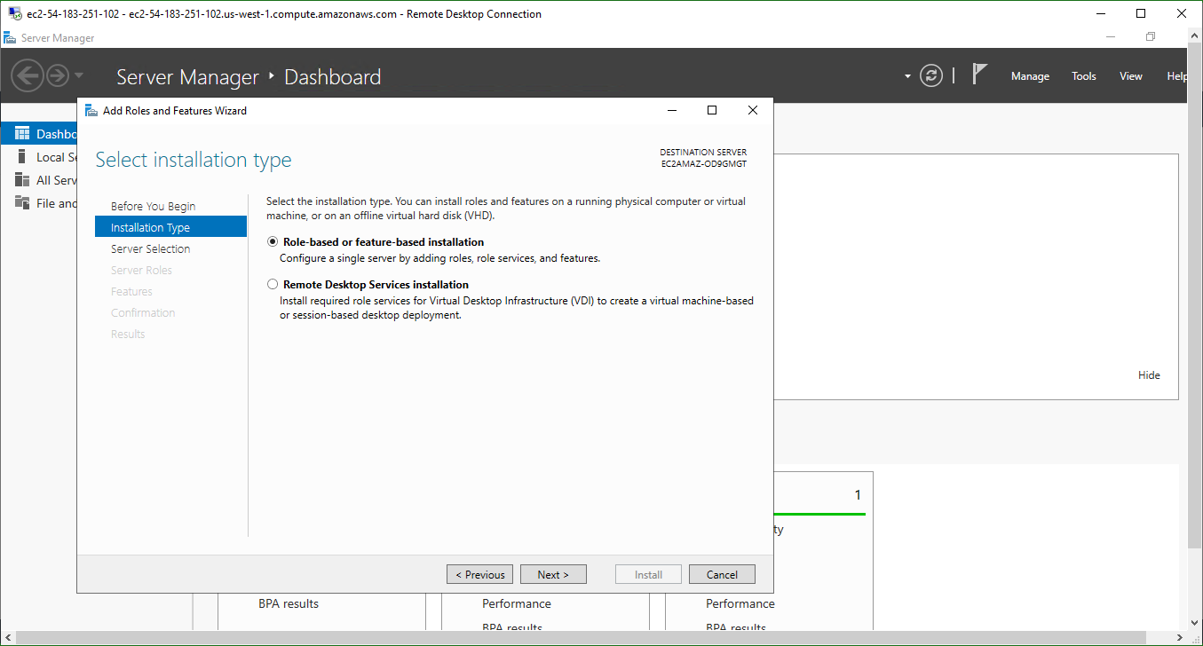

1. Click Next.

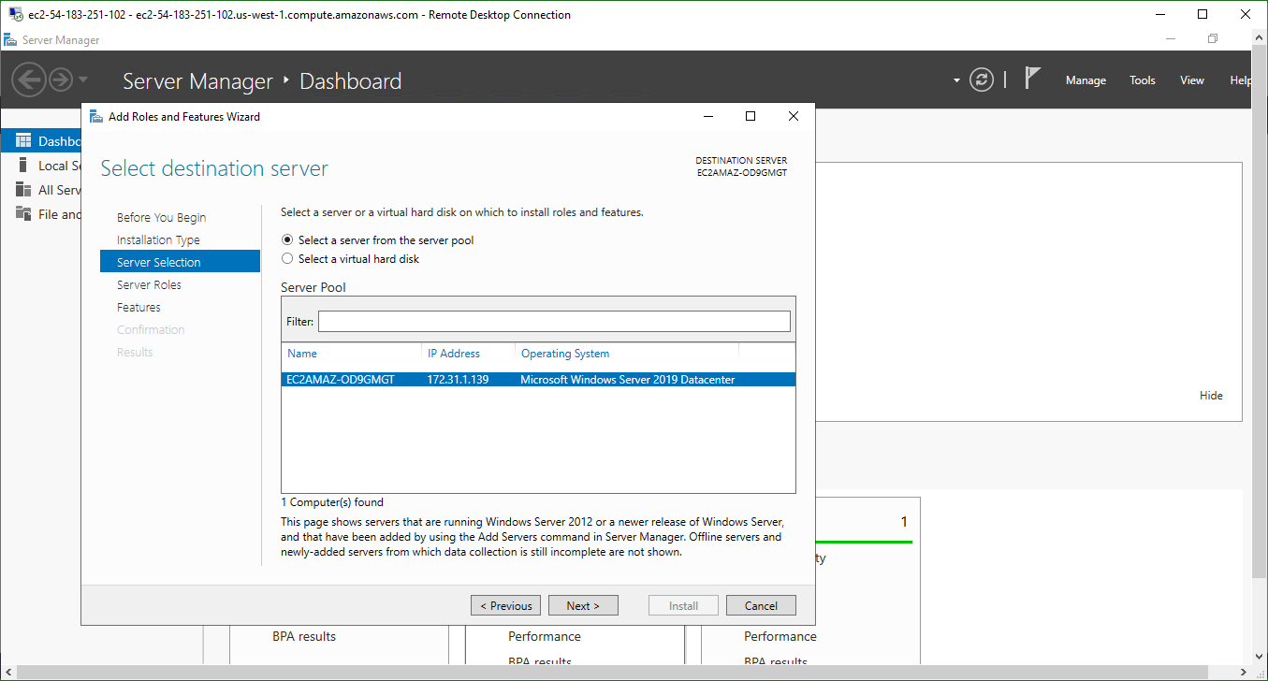

1. Here Select Weh Server(IIS) then Click on Next.

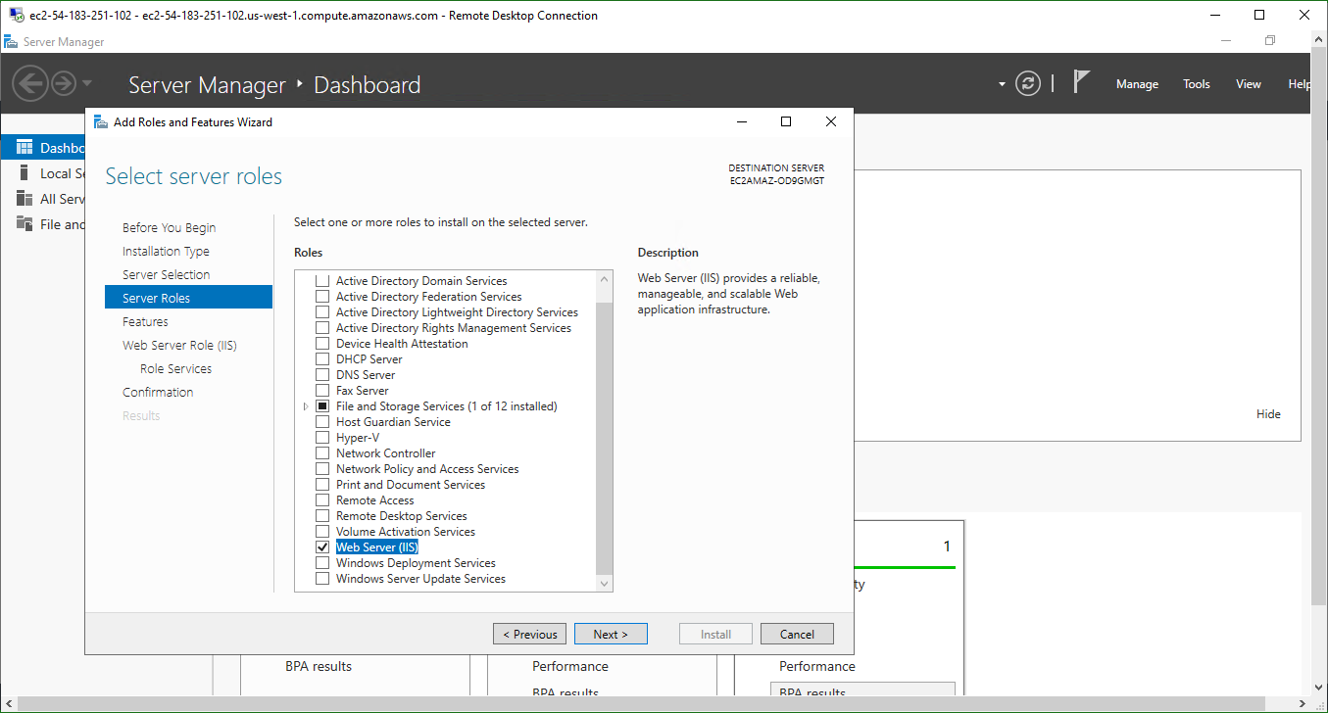

1. Click Next.

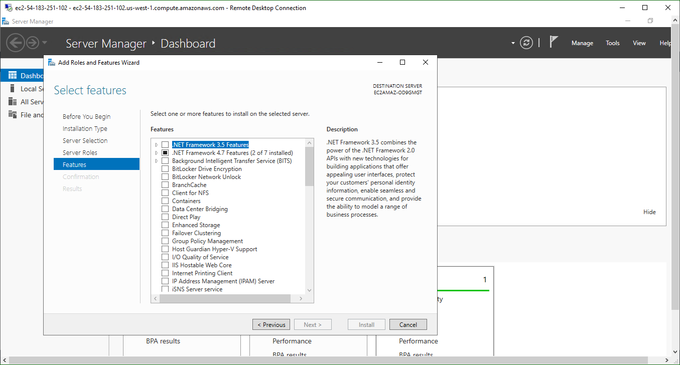

1. Click Next.

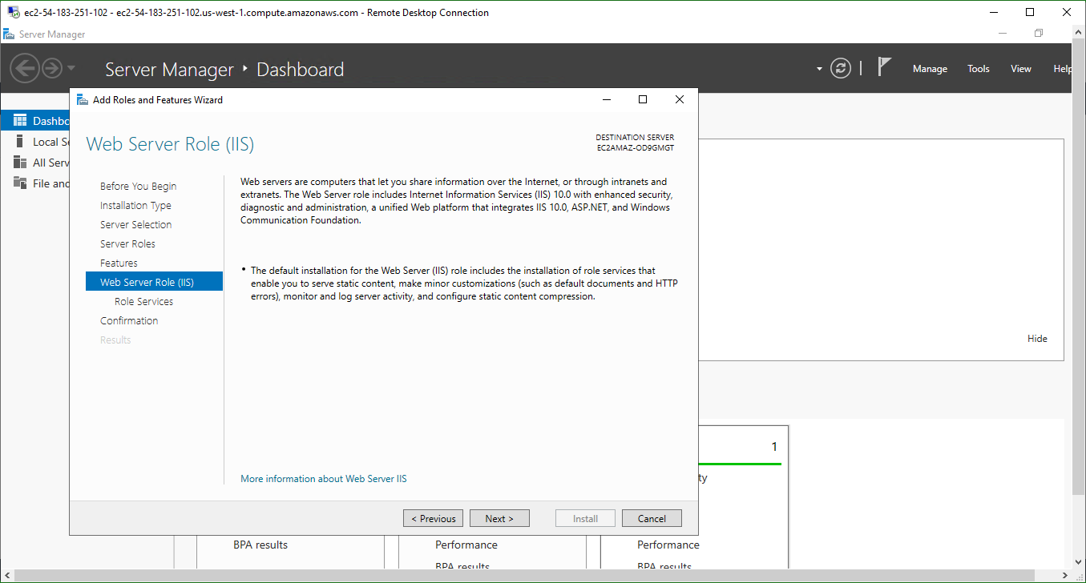

1. Click Next.

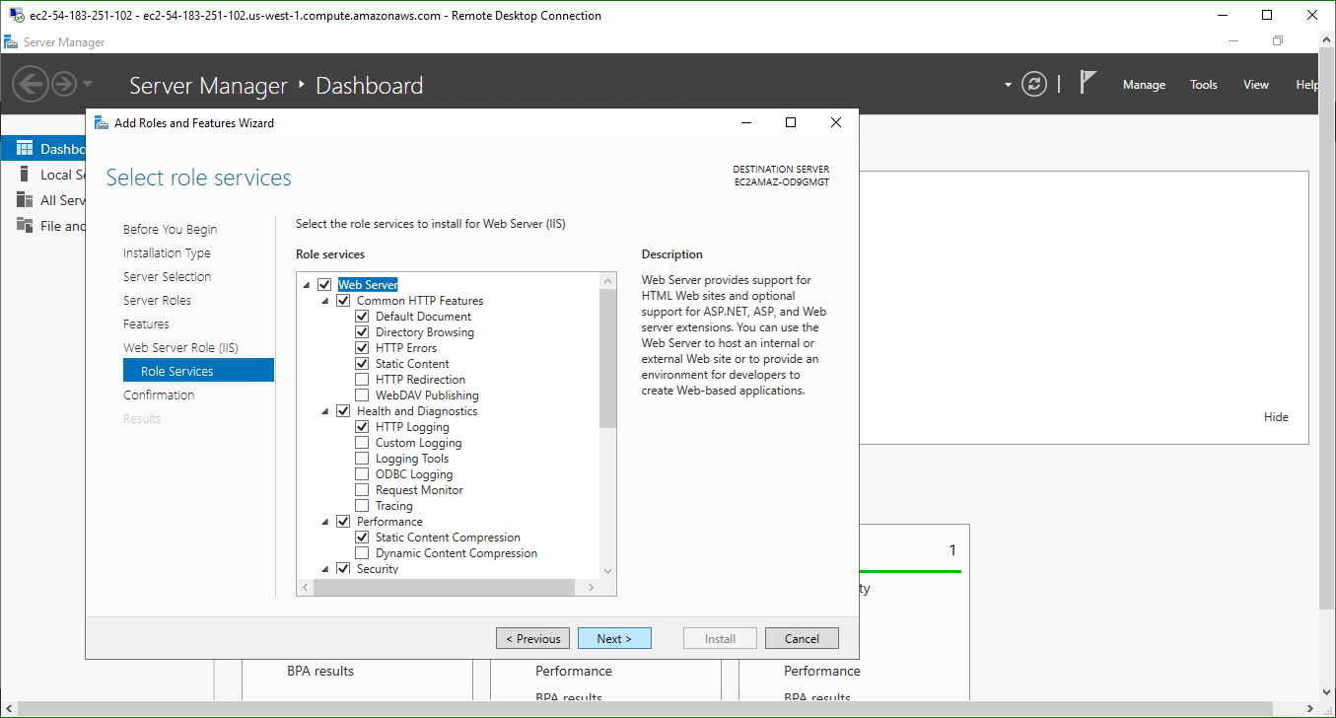

1. Then this Screen will appear. go to Internet Explorer and type <http://localhost/>

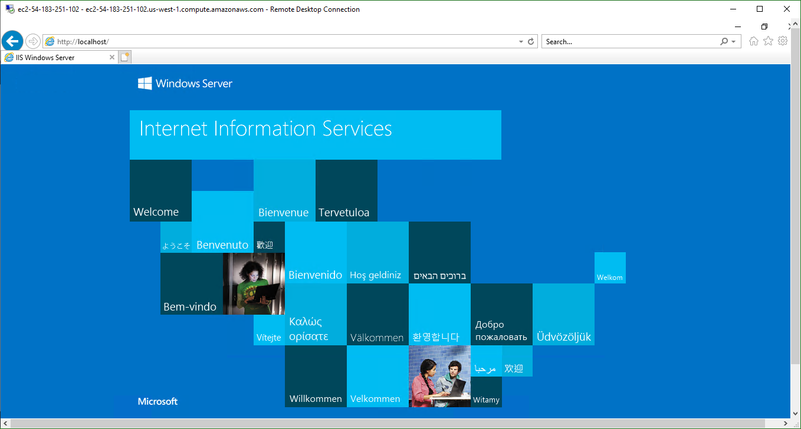

1. Now create web page and Save it at location c:/inetpub/wwwroot as index.html.

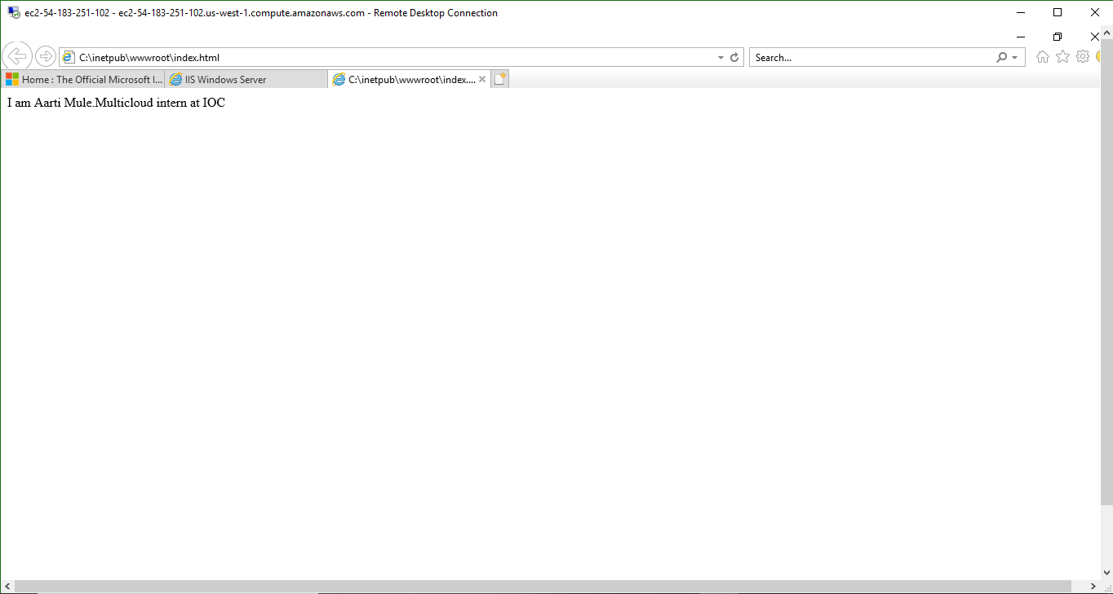

Successfully completed.